TrustDecision Project Delivery Team

Project Team Organization Structure
After the bidder wins the bid, we will establish a project delivery team, which includes multiple important roles. The personnel on the client side mainly focus on cooperation and internal coordination.
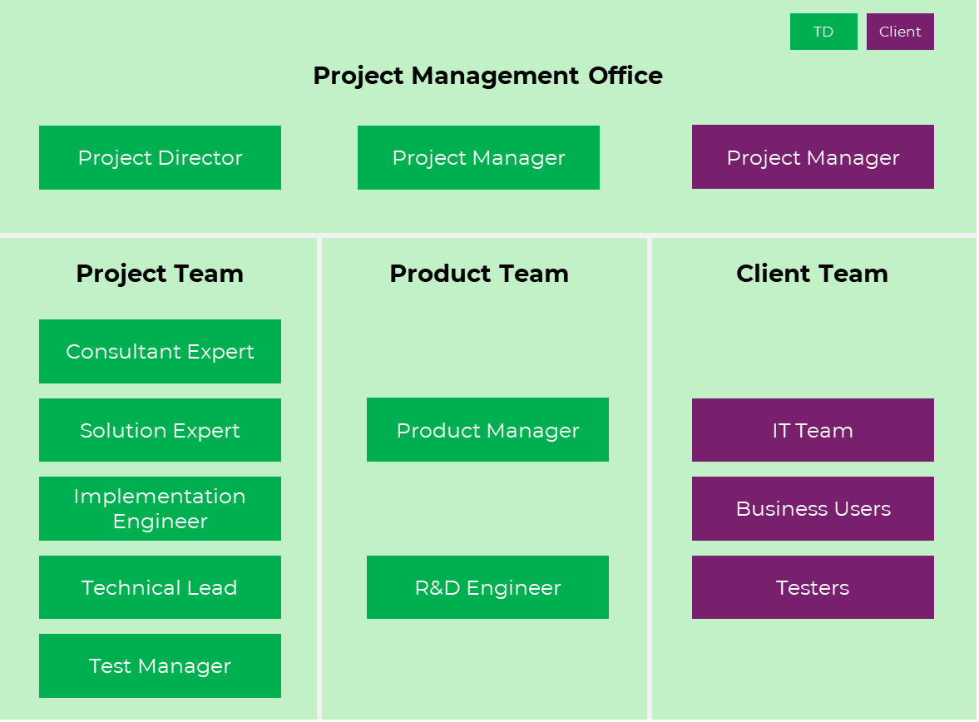
Bidder Team Roles and Responsibilities are as follows. The personnel list has been arranged according to the schedule of the HLA project. In case of any personnel changes during the process, the bidder will ensure that the project work will not be affected.

No | Role | Responsibility | Name | Base
 | Project Director | Responsible for the collaborative management of the project, resource scheduling and milestone node control. | Cao Dongfang | Base Malaysia
 | Technical Lead | Responsible for system deployment and system interfacing and coordination. | Lam Chen Riang | Malaysian
 | Solution Architect Expert | Analyzing business requirements, designing the overall technical solution, integrating various technical components, and ensuring the feasibility and efficiency of the solution | Ng Jian Qin | Malaysian
 |  |  | Lee Lin Yuan | Malaysian
 |  |  | Lee Jen Wai | Malaysian
 | Project Manager | Responsible for project requirements, schedule, scope, and quality Control and collaborative management of the project team. | Fan Mengdi | Project Based
 | Consultant Expert | Responsible for strategy definition, model development. | Yang Ruiqi | Project Based
 | Technical Manager &Implementation Engineer | Responsible Project research and development collaborative management and architecture design. | Zhou Kuikui | Project Based
 | R&D Senior Product Manager | Responsible for product question and answer, documentation support. | Gao Lei | Project Based
 | R&D Solution Manager | Responsible for the communication of the project's individual needs, solution planning. | Fan Kaiyi | Project Based
 | R&D Engineer | Responsible for project system research and development | Multiple engineers | Remote
 | Test Manager | Responsible for system quality assurance | Wu Canbin | Project Based

CV
Name |  | Cao Dongfang | Gender | Male | Mobile |  | +60148513998 |  |  | 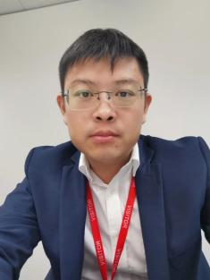
Position |  | TD international delivery VP  Project Director |  |  | Work Location |  | Malaysia
English Name |  | Henry | Email |  | dongfang.cao@trustdecision.com
Social contact |  | Whatsapp： +60148513998, WeChat 13684995397
Education
Start |  | End | University |  |  | Major |  |  |  | Qualification
2002.9 |  | 2006.7 | Hebei University of Technology |  |  | Bachelor, Measurement and Control Technology and Instruments |  |  |  | Bachelor
Employment History
Start Date |  | End Date | Full Company Name |  | Department |  |  |  | Position
2024.12 |  | Now | TrustDecision (Malaysia) Sdn Bhd |  | International Business Department |  |  |  | VP of Overseas Business Delivery
2021.11 |  | 2024.12 | Amazon Web Services (AWS) |  | AWS GCR Technical Support |  |  |  | Technical Support Manager
2011.05.31 |  | 2021.10 | Huawei Technologies Co., Ltd. |  | Enterprise Business BG |  |  |  | Delivery and Service Manager
2006.07 |  | 2011.05 | Foxconn Technology Group |  | HP Server R & D Department |  |  |  | R & D and Test Manager
Project Experience
Start Date |  | End Date | Project Name |  | Project Scope |  |  |  | Position
2024.12 |  | now | HLB FDS |  | Build fraud detection system on HLB |  |  |  | Project Director
2012.8 |  | 2017.4 | Huawei Malaysia projects |  | Responsible for the delivery of Huawei's projects in Malaysia, including IT and network, data center projects in the government, finance and other sectors. |  |  |  | Service Director
Skill Set
Skill | English: CET6， TOEIC805，PTE74  PMP(3A)  AWS Certified Solutions Architect - Associate  AWS Certified Solutions Architect - Professional  AWS Certified Database - Professional  AWS Certified Security - Professional  AWS Certified Data Analytics - Professional  AWS Certified Machine Learning - Professional  AWS Certified DevOps Engineer - Professional  AWS Certified Advanced Networking - Professional  AWS Certified Al Practitioner |  |  |  |  |  |  | Huawei Certification  HCIE Storage;  HCNP Storage; HCNA Storage  HCNP Cloud;  HCNA Cloud，HCNA Cloud service  HCNP,HCNA Router&Switch

Name |  | Lam Chen Riang | Gender | Male | Mobile |  | +60124765408 |  | 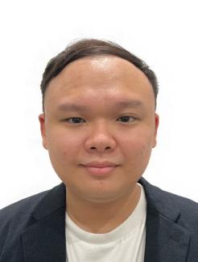
Position |  | Technical Lead |  |  | Work Location |  | Malaysia
English Name |  | Chen Riang | Email |  | chenriang.lam@trustdecision.com
Social contact |  | Whatsapp： +60124765408, WeChat chenriang
Education
Start |  | End | University |  |  | Major |  |  | Qualification
2014 |  | 2017 | Universiti Tunku Abdul Rahman (UTAR), Selangor |  |  | Science (Hons) Software Engineering |  |  | Bachelor
Employment History
Start Date |  | End Date | Full Company Name |  | Department |  |  | Position
2024.3 |  | Now | TrustDecision (Malaysia) Sdn Bhd |  | International Business Department |  |  | Technical manager
2020.3 |  | 2024.3 | GBG (Malaysia) |  | Software Product department |  |  | Senior Research & Development Engineer
2017.6 |  | 2020.3 | Experian (Malaysia) |  | Software Product department |  |  | Software Engineer II
2016.10 |  | 2017.06 | HF Technology |  | Software Product department |  |  | Software Engineer (INTERN)
Project Experience
Start Date |  | End Date | Project Name |  | Project Scope |  |  | Position
2023.12 |  | 2024.3 | New Fraud Management system |  | Contributed the end-to-end implementation of a cloud-native banking solution for a major Thailand financial institution, modernizing legacy systems. Optimized performance, security, and compliance, ensuring a seamless go-live |  |  | Technical consultant
Skill Set
Skill | A highly skilled software engineer proficient in Java, Python, with expertise in cloud platforms and databases. Experienced in the financial sector, having played a key role in delivering a major banking project at GBG, contributing from RFP to implementation.

Name |  | Ng Jian Qin | Gender | Male | Mobile |  | +601151391940 | 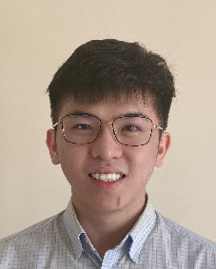
Position |  | Presales Consultant  &Solution Architect Expert |  |  | Work Location |  | Malaysia
English Name |  | JQ | Email |  | jianqin.ng@trustdecision.com
Social contact |  | Whatsapp： +601151391940
Education
Start |  | End | University |  |  | Major |  | Qualification
2013 |  | 2017 | Universiti Tunku Abdul Rahman (UTAR) |  |  | Statistical Computing and Operation Research |  | Bachelor
Employment History
Start Date |  | End Date | Full Company Name |  | Department |  |  | Position
2023.11 |  | Now | TrustDecision (Malaysia) Sdn Bhd |  | International Business Department |  |  | Presales Consultant
2017.9 |  | 2023.10 | Juris Technologies Sdn Bhd |  | Project Delivery Department |  |  | Associate Manager
Project Experience
Start Date |  | End Date | Project Name |  | Project Scope |  |  | Position
2024.12 |  | now | HLB FDS |  | - HLB New Fraud Detection System |  |  | Solution Architect
2022.7 |  | 2023.10 | Maxis Collection System |  | - Served as Functional Lead and primary PIC for Collection & Recovery System for a telecomcompany.  - Led FSD delivery, SIT, UAT testing, and obtained project sign-off. |  |  | Functional Lead
2019.6 |  | 2022.6 | Hong Leong Bank Commercial Loan Origination Project |  | - Delivered a system for Commercial Loan Origination which involves Lead Management, Origination Process, Approval Workflow, LO Acceptance, Solicitor Documentation Process, Collateral Management, etc.  - Oversaw Post-Implementation Support, ensuringissue resolution within SLA |  |  | Functional Lead
2017.1 |  | 2019.6 | Maybank Rent-to-Own Project |  | - Delivered an end-to-end straight through processing system for Real Estate Rent To OwnScheme that involved Customer Application, Property Agent Onboarding, CreditAssessment, LO Acceptance, Documentation Process, Option to Purchase/Sell, etc. |  |  | Business Analyst
Skill Set
Skill | Experienced professional in managing sales cycle from initial contact to customer acquisition, with proven expertise inleading software development teams in delivering solutions for banks and financial institutions. Proficient in project planning, business requirement gathering, and process consulting. Committed to driving sales revenue growth by solving client's current and emerging challenges with innovative solutions. Skilled in collaborating with multiple stakeholders towards completing complex task and meeting client expectations.

Name |  | Lee Lin Yuan | Gender | Female | Mobile |  | +601116553434 |  | 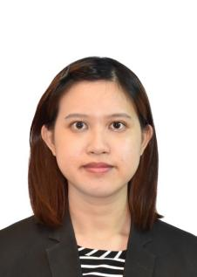
Position |  | Presales Consultant  &Solution Architect Expert |  |  | Work Location |  | Malaysia
English Name |  | Lin | Email |  | linyuan.lee@trustdecision.com
Social contact |  | Whatsapp： +601116553434, WeChat lly121097
Education
Start |  | End | University |  |  | Major |  |  | Qualification
2016 |  | 2018 | Universiti Tunku Abdul Rahman (UTAR), Selangor |  |  | Bachelor of Science (Hons) Financial Mathematics |  |  | Bachelor
Employment History
Start Date |  | End Date | Full Company Name |  | Department |  |  | Position
2025.1 |  | Now | TrustDecision (Malaysia) Sdn Bhd |  | International Business Department |  |  | Solution Architect Expert
2019.12 |  | 2025.1 | Huawei Technologies |  | Asia Pacific IT Business Serv Department |  |  | Product & Solution Engineer
2019.7 |  | 2019.12 | Hong Leong Bank |  | Corporate Banking Department |  |  | Corporate Banking Specialist
2016.10 |  | 2017.06 | Royal Bank Canada |  | Global Tax and Account Services Department |  |  | Global Tax Operation Specialist
Project Experience
Start Date |  | End Date | Project Name |  | Project Scope |  |  | Position
2025.1 |  | 2025.3 | Anti Fraud System and Credit Risk Modelling |  | Participate in solution design and technical consulting for financial institutions across the Middle East &  Southeast Asia  Designed and delivered customized proof-of-concepts (POCs). |  |  | Solution Architect
2024.6 |  | 2025.1 | 5G Business Transaction flow for Telco Business |  | Head of Solutions for the Malaysia Representative Office; led the design and delivery of the Malaysia  5G Transaction Flow project to optimize IT solutions. |  |  | Product & Solution Engineer
2020.12 |  | 2024.5 | Implementation of New ERP system |  | As a Led of PMO in enterprise-level ERP implementation across 22 Asia-Pacific offices, managing a team of over 300 testers and developers |  |  | Product & Solution Engineer
Skill Set
Skill | Google Project Management Certificate  Huawei ERP Consultation Certification  Google IT Automation with Python Specialization  Microsoft Certified: Azure AI Engineer Associate  Google Data Analytics Certificate  Huawei IT Security Certification  Programming Languages (Python, Vue.js, Html,css)

Name |  | Lee Jen Wai | Gender | Male | Mobile |  | +60179067968 |  | 
Position |  | Presales Consultant  &Solution Architect Expert |  |  | Work Location |  | Malaysia
English Name |  | Jen Wai | Email |  | Jenwai.lee@trustdecision.com
Social contact |  | Whatsapp： +60179067968
Education
Start |  | End | University |  |  | Major |  |  | Qualification
2010 |  | 2013 | Berjaya University College of Hospitality |  |  | Culinary Art |  |  | Diploma
2013 |  | 2015 | Alison |  |  | Business Adminstration |  |  | Diploma
Employment History
Start Date |  | End Date | Full Company Name |  | Department |  |  | Position
2024.1 |  | Now | TrustDecision (Malaysia) Sdn Bhd |  | International Business Department |  |  | Solution Architect Expert
2016.1 |  | 2024.1 | Akulaku Group |  | Global Team |  |  | Director of Strategic Partnerships
2017.12 |  | 2018.9 | Avavaz |  | Founding Member |  |  | Chief Operating Officer
2014.10 |  | 2016.1 | Iappay |  | International Business Department |  |  | Regional Sales Manager
Project Experience
Start Date |  | End Date | Project Name |  | Project Scope |  |  | Position
2023.1 |  | 2024.1 | Paypaya |  | To launch a nano loan product from scratch in Thailand Bangkok with a team of less than 10. |  |  | Business Development
2022.1 |  | 2023.1 | Samsung Financing ID |  | Collaborate with DMI the will of MUFG to work on 2nd channel for Samsung Financing to replace Kredivo |  |  | Project Manager
2020.1 |  | 2022.12 | Silvrr+ |  | Relaunch & rebrand Akulaku Malaysia to Silvrr+ . First month of launching manage to generate 1M USD revenue during covid times |  |  | Malaysia Country Head
Skill Set
Skill | My expertise in BNPL, digital lending, and financial technology to drive product innovation, enhance strategic partnerships, and strengthen risk management frameworks.

Name |  | Fan Mengdi | Gender | Female | Mobile | +86 13588723398 |  | 
Position |  | Senior Project Manager |  |  | Work Location | Project Based
English Name |  | Mengdi | Email |  | mengdi.fan@tongdun.net
Social contact |  | Whatsapp: +8613588723398  WeChat: 13588723398
Education
Start |  | End | University |  | Major |  |  | Qualification
2013.09 |  | 2014.07 | Georgia Southwestern State University |  | MBA |  |  | Master
2011.01 |  | 2013.05 | Georgia Southwestern State University |  | Fine Art Department |  |  | /
2008.09 |  | 2012.07 | Tianjin University of Science and Technology |  | visual communication design |  |  | Bachelor
Employment History
Start Date |  | End Date | Full Company Name |  | Department |  | Position
2022.08 |  | Now | Tongdun Technology Co., Ltd. |  | International Business Department |  | Senior Project Manager
2019.10 |  | 2022.7 | Zhejiang Youshu Digital Intelligence Technology Co., Ltd. |  | General Manager Office |  | Project Manager  PMO Manager  Solution Consulting
2014.10 |  | 2019.10 | Zhejiang Tuxun Technology Co., Ltd. |  | Enterprise Business BG |  | General manager assistant  Project Manager  Solution Manager
Project Experience
Start Date |  | End Date | Project Name |  | Project Scope |  | Position
2024.10 |  | now | Xiamen Airlines ticket sales anti - crawler system |  | Build an anti-crawler system system on XiamenAir |  | Project Manager
2024.01 |  | 2024.09 | Coupang FDS |  | Build an Fraud detection system on Coupang |  | Project Manager
2022.10 |  | 2023.07 | Tailong Bank model asset management system |  | Build a model life cycle management platform on Tailong |  | Project Manager
Skill Set
Skill | English: CET4，GMAT  Enterprise Trainer（Technician）

Name |  | YangRuiqi | Gender | Male | Mobile |  | +60194462975 |  | 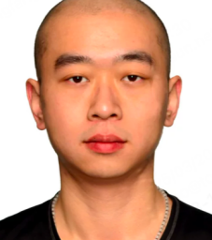
Position |  | TD Senior Consultant |  |  | Work Location |  | Project Based
English Name |  | Ricky | Email |  | ruiqi.yang@tongdun.net
Social contact |  | Whatsapp： +60194462975, WeChat 13986036703
Education
Start |  | End | University |  |  | Major |  |  | Qualification
2019.1 |  | 2021.3 | University of Toronto, St. George Campus |  |  | Financial Engineering |  |  | Master
2012.9 |  | 2018.11 | University of Toronto, St. George Campus |  |  | Actuarial Science / Statistics |  |  | Bachelor
Employment History
Start Date |  | End Date | Full Company Name |  | Department |  |  | Position
2024.4 |  | Now | Tongdun Technology Co., Ltd. |  | Technical Department of Software Products |  |  | Consultant Expert
2022.5 |  | 2024.3 | Canadian Imperial Bank of Commerce |  | Anti - fraud Analysis Department |  |  | Senior Analytical Advisor
2021.5 |  | 2022.5 | DeepAI |  | Quantitative Investment Department |  |  | Machine Learning Researcher
Project Experience
Start Date |  | End Date | Project Name |  | Project Scope |  |  | Position
2024.12 |  | now | HLB FDS |  | HLB New Fraud Detection System |  |  | Consultant Expert
Skill Set
Skill | I can manage and optimize the anti-cashing fraud system, identify risks through big data mining, and upgrade the system. I am able to collaborate with multiple departments to provide professional advice and customize strategies. I participate in the modularization of risk control strategies and system transformation. I am proficient in handling financial data, replicating algorithms, and optimizing investment models. I can develop portfolio systems, analyze model performance, and establish prediction systems for risk control.

Name |  | ZhouKuiKui | Gender | Male | Mobile |  | 13646828909 |  | 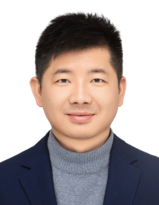
Position |  | Technical Manager &Implementation Engineer |  |  | Work Location |  | Project Based
English Name |  | KuiKui | Email |  | kuikui.zhou@tongdun.net
Social contact |  | Whatsapp： +8613646828909, WeChat 13646828909
Education
Start |  | End | University |  |  | Major |  |  | Qualification
2008.9 |  | 2012.7 | China Jiliang University |  |  | Electronic Science and Technology |  |  | Bachelor
2012.9 |  | 2015.1 | Zhejiang University of Technology |  |  | Electronic and Communication Engineering |  |  | Master
Employment History
Start Date |  | End Date | Full Company Name |  | Department |  |  | Position
2019.4 |  | Now | Tongdun Technology Co., Ltd. |  | Technical Department of Software Products |  |  | Technical Expert
2018.11 |  | 2019.4 | Ant Group(Financial ) |  | Financial Software Products |  |  | Developer Expert
2015.3 |  | 2018.11 | Bangsheng Technology |  | Financial Software Products |  |  | Java Developer Expert
Project Experience
Start Date |  | End Date | Project Name |  | Project Scope |  |  | Position
2024.12 |  | now | HLB FDS |  | HLB New Fraud Detection System |  |  | Technical Manager
2023.9 |  | 2024.5 | Huaxia Bank FDS |  | The Enterprise-level Anti-fraud In-transaction Risk Control Platform Project of Huaxia Bank in 2023 |  |  | Solution Architect
2022.11 |  | 2023.3 | Suzhou Bank Risk Control project |  | Intelligent Risk Control Decision-making Platform of Suzhou Bank |  |  | Solution Architect
2021.11 |  | 2022.3 | Hangzhou Bank project |  | The Credit Localization Replacement Project of Hangzhou Bank |  |  | Solution Architect
2020.11 |  | 2022.10 | Bank Of China FDS |  | Anti-fraud Project of BOC Consumer Finance |  |  | Technical Manager
2020.10 |  | 2021.3 | Suzhou Rural Commercial Bank FDS project |  | Anti-fraud Project of Suzhou Rural Commercial Bank |  |  | Technical Manager
2019.6 |  | 2020.9 | Tailong Bank |  | Online Small-amount Anti-fraud Project of Tailong Bank |  |  | Technical Manager
Skill Set
Skill | I have 10 years of work experience in the financial anti-fraud industry, and I have participated in the architecture design and development of multiple large-scale financial anti-fraud projects. The client sectors cover banks, consumer finance institutions, Internet finance institutions, and acquiring institutions, etc., and the business areas cover credit, transactions, the new economy, offline acquiring, etc.  I also have 2 years of experience in managing R&D teams.  Skills, Technologies, and Business Expertise:  ·Familiar with the full-process risk control business of banks, such as credit and transactions.  ·Familiar with the architecture design of anti-fraud systems.  ·Familiar with commonly used Java open-source components and development frameworks.

Name |  | Gao Lei | Gender | Male | Mobile |  | +86 15695889918 |  | 
Position |  | R&D Senior Product Manager |  |  | Work Location |  | China/Project Based
English Name |  | Eric | Email |  | lei.gao@tongdun.net
Social contact |  | WeChat 15695889918
Education
Start |  | End | University |  |  | Major |  |  | Qualification
2007.09 |  | 2010.01 | Peking University |  |  | Master, Software Engineering |  |  | Master
2003.09 |  | 2007.07 | Liaocheng University |  |  | Bachelor Degree in Mathematics |  |  | Bachelor
Employment History
Start Date |  | End Date | Full Company Name |  | Department |  |  | Position
2018.01 |  | Now | Tongdun Technology Co., Ltd. |  | Product development department |  |  | Product Manager
2016.06 |  | 2018.01 | Merit Interactive Co.,Ltd. |  | Product development department |  |  | Product Manager
2013.05 |  | 2016.06 | Visenze Co., Ltd. |  | Product development department |  |  | Product Manager
Project Experience
Start Date |  | End Date | Project Name |  | Project Scope |  |  | Position
2024.12 |  | now | HLB FDS Project |  | HLB New Fraud Detection System |  |  | Product Manager
2023.03 |  | 2024.8 | Huaxia Bank - Model Development Platform Project |  | Build bank - wide model asset & integrated management platform |  |  | Product Manager
2022.03 |  | 2022.12 | Postal Savings Bank of China - Postbrain Knowledge Graph Platform Project |  | Establish knowledge graph platform with three scenarios |  |  | Product Manager
2021.05 |  | 2022.03 | China CITIC Bank Credit Card Center - Model Management and Monitoring Platform Project |  | Construct intelligent model management & monitoring system |  |  | Product Manager
2020.01 |  | 2022.05 | China Guangfa Bank - Retail Risk Control Anti - fraud Relationship Network Project |  | Identify retail anti - fraud risks based on graph mining |  |  | Product Manager
Skill Set
Skill | Technical Competence  Proficient in building model management platforms. At Huaxia Bank, I developed a bank - wide platform covering the entire model lifecycle. Led the construction of the knowledge graph platform at Post Office Savings Bank, creating three application scenarios, demonstrating the ability to build complex technical systems.  Product Management  Served as the product owner in multiple projects. Built an intelligent model management and monitoring system at China CITIC Bank Credit Card Center and was in charge of the anti - fraud relationship network project at China Guangfa Bank, precisely guiding project directions.

Name |  | Kaiyi Fan | Gender | Female | Mobile |  | +86 13848713357 |  | 
Position |  | R&D Solution Manager |  |  | Work Location |  | China/Project Based
English Name |  | Kaiyi | Email |  | kaiyi.fan@tongdun.net
Social contact |  | Whatsapp/WeChat: +86 13848713357
Education
Start |  | End | University |  |  | Major |  |  | Qualification
2023.1 |  | 2024.7 | University of Sydney |  |  | Master of Interaction Design and Electronic Arts |  |  | Master
2022.8 |  | 2022.12 | University of Sydney |  |  | Master of Digital Communication and Culture |  |  | Master
2017.8 |  | 2022.5 | Indiana University Bloomington |  |  | Bachelor of Arts in Media |  |  | Bachelor
Employment History
Start Date |  | End Date | Full Company Name |  | Department |  |  | Position
2024.8 |  | Now | Tongdun Technology Co., Ltd. |  | Digital Finance Department - Software Product Technology Department - International Product Team |  |  | Product Manager
Project Experience
Start Date |  | End Date | Project Name |  | Project Scope |  |  | Position
2024.12 |  | Now | HLB FDS |  | Provide HLB with Fraud Detection System for risk prevention and control in banking and financial services. |  |  | Product Manager
Skill Set
Skill | English: TOEFL 92  Figma/Axure  Miro/Xmind  Adobe Id/Pr/Ae  Slack/Microsoft Teams/Zoom

Name |  | Wu Canbin | Gender | Male | Mobile |  | +8615918705470 |  | 
Position |  | Software QA Engineer |  |  | Work Location |  | Project Based
English Name |  | Robin | Email |  | ty-canbin.wu003762@tongdun.net
Social contact |  | WeChat 15918705470
Education
Start |  | End | University |  |  | Major |  |  | Qualification
2021.9 |  | 2017.7 | Guangzhou Business College |  |  | Automotive Electronic Technology |  |  | Bachelor
Employment History
Start Date |  | End Date | Full Company Name |  | Department |  |  | Position
2021.7 |  | Now | Tongdun Technology |  | Digital Finance Department |  |  | Senior Software Test Engineer
Project Experience
Start Date |  | End Date | Project Name |  | Project Scope |  |  | Position
2021.09 |  | 2022.01 | Bank of Guangfa |  | Corporate Credit System |  |  | Senior Software Test Engineer
2022.02 |  | 2023.06 | Bank of Huaxin |  | Intelligent Risk Control Syste |  |  | Senior Software Test Engineer
2023.05 |  | 2023.09 | Account Application |  | Product 2401 Period |  |  | Senior Software Test Engineer
2024.04 |  | 2024.05 | Tiance Credit Version |  | Bank of Sichuan A Case Management Function Development |  |  | Senior Software Test Engineer
Skill Set
Skill | FDS system testing, software testing, user UAT (User Acceptance Testing) testing, and performance optimization

